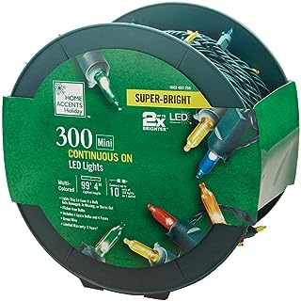

1. **Name:** Home Accents Holiday 300-Light LED Smooth Mini Super Bright Multi-Reel TY560-1715-1M

**Price: $16.99**

[**About this item**](javascript:void(0))

* Meets UL-listing safety standards
* 98.4 ft. of 300 multi-color, mini LED lights
* LED bulbs provide lasting, energy-efficient operation
* Red Blue Yellow Green Orange

# 

# Name: Home Accents Holiday 8 ft. Lighted Length with 24-Lights Large Dot LED Warm White Ultra Slim Wire Light Operated

# Price: $49.99

[**About this item**](javascript:void(0))

* LED
* 3 AA Battery Operated (not Included)
* Multi-Function

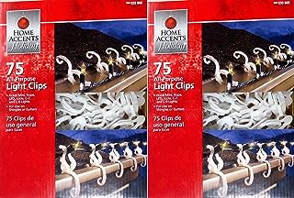

1. **Name:** Home Accents Holiday All-Purpose, Shutter, Gutter Light Clips 2 Pack (150 Clips)

**Price: $36.99**

[**About this item**](javascript:void(0))

* 2 Boxes of 75 Clips
* 150 Clips Total For Easy Hanging Of Christmas Lights

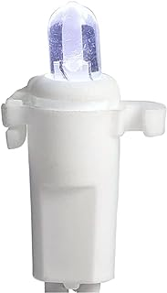

# Name: Home Accents Holiday 200 LED Dome Icicle Lights

**Price: $22.99**

[**About this item**](javascript:void(0))

* Links to up to 15 other sets for wide coverage LEDs offer bright light and reliability for seasonal fun
* Ideal for lighting both indoor and outdoor scenes Cool white color completes your winter holidays
* 200 cool white LEDs add liveliness to your holiday setup

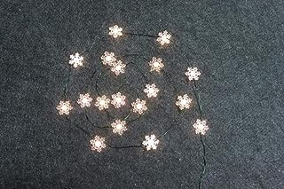

# Name: Home Accents Holiday LED Warm White Snowflake (1" Size) Ultra-Wire Light (18 Lights, 6 feet in Length)

# Price: $22.99

[**About this item**](javascript:void(0))

* Led Ultra-Wire Light

# 

# Name: Sunlite 40971 LED S14 String Light Bulb, 2 Watts (25W Equivalent), Medium E26 Base, Party Decoration, Holiday Lighting, Transparent, Dimmable, UL Listed, Amber, 6 Count

# Price: $23.99

[**About this item**](javascript:void(0))

* UPGRADE TO LED - Easily upgrade your old incandescent bulbs with energy efficient LED technology. Sunlite's LED decorative light bulb is the perfect option for your space when you are looking to add some flare with a colored light
* ENERGY EFFICENT - Using only 2 watts of energy, this bulb will give you an output equal to a 25 watt incandescent light bulb
* PARTY LIGHTS - Ideal for parties, holiday lighting or to show support for your special causes. These dimmable bulbs can be used both indoor and outdoor.
* DIMMABLE - These bulbs will last an estimated 15,000 hours. Tested compatible dimmers; Leviton 1H45O6 6633-LI 6633-P 6683-10Z Leviton DV-600P DV-603PG DVCL-153P S-600P S-603P TGCL-153PH
* SAFER CHOICE - These bulbs contain no mercury or other harmful chemicals. Tested and certified by the high standards of UL make this bulb a safe option for your home or office

# 

# Name: Halloween 6 ft. Lighted Length with 18-Light Ghost-Shaped LED Ultra-Wire Home Accent

# Price: $22.99

[**About this item**](javascript:void(0))

* Halloween 6 ft. lighted length with 18 Ghost-Shaped LED ultra-wire light
* Timer included for 6 hours on and 18 hours off programming
* 3 AA Battery Operated (not included)

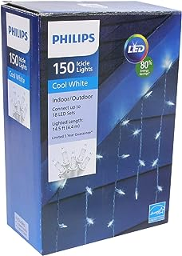

# Name: PHILIPS Faceted Mini Icicle Lights – 150 Cool White Faceted Mini LED Icicle Lights on White Wire - Indoor or Outdoor Winter Decorating

**Price: $17.08**

[**About this item**](javascript:void(0))

* ENERGY-SAVING AND LONG-LASTING - LED lightbulbs are highly energy-efficient, lasting much longer than most incandescent sets! Each energy-saving LED set is covered by a 5-year Guarantee
* WEATHER-PROOF - These winter light sets are weatherproof, making them the perfect lighting for your outdoor space. Use these decorative lights inside or outside without having to stress about damage from rain or snow.
* BEAUTIFUL DECORATION FOR THE HOLIDAYS - Add a cool glow to your space with these faceted mini icicle lights. Philips icicle lights are great for illuminating your porch, deck, balcony, windows, or any other space. Icicle string lights create a fun, festive look that can be enjoyed all season long!
* LENGTH AND BULB COUNT - These faceted mini icicle lights have a 14.5-foot lighted length and a 24-inch lead-in on white wire. The 150 bulbs are in a 4-6-4-6 drop pattern, with the 30 drops spaced 6 inches apart. Connect up to 18 strands for a total of 2700 lights
* SAFE AND MULTIPURPOSE - These light strings have cool running LED bulbs along with a replaceable fuse in the plug that prevents overload. Philips decorative lights have passed rigorous UL safety testing. Use these winter lights to decorate and illuminate any place indoors or outdoors - from windows to trees to fences and more!

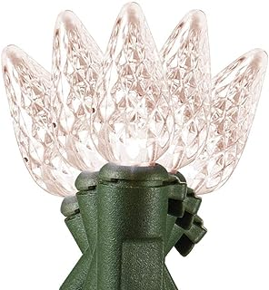

# Name: Home Accents Holiday 8 ft. 20-Light LED Warm White Battery Operated C3 LED Light String L6020003WU01

**Price: $20.99**

[**About this item**](javascript:void(0))

* LED
* 3 AA Battery Operated (not Included)
* indoor outdoor

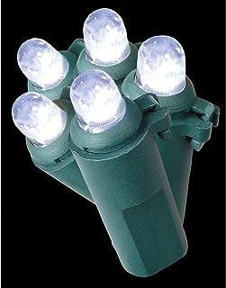

# Name: Home Accents Holiday 200-Light LED Cool White Dome Light String

**Price: $17.99**

[**About this item**](javascript:void(0))

* LED
* Dome
* Cool White
* Ultra-efficient, eco-friendly LED lighting
* Suitable for both indoor and outdoor decorating